RIAC PICNIC IN THE PARK 2023 REGISTRATION FORM
We would like you to register your interest in attending this year’s Picnic in the Park and make a donation to LauraLynn. You can still donate on the day but to facilitate the smooth running of the event we would be delighted if people would register and donate in advance.

Name:
Email:
Phone:
Car Make:
Car Model:
Car Year:
Have you donated to Laura Lynn?
I wish to donate: € 10 [ ] € 20[ ] € 30 [ ] € 50 [ ] Other [ ]

Cheque: [ ] Payable to LauraLynn

Credit Card or Debit Card – processed by RIAC
Credit Card No: _ _ _ _ _ _ _ _ _ _ _ _ _ _ _ _
Expiry Date. MM/YY _ _ /_ _ CVV _ _ _

Send to: Picnic in the Park c/o of RIAC 34 Dawson Street Dublin 2
QR CODES ON REVERSE – JUST SCAN WITH YOUR PHONE CAMERA AND FOLLOW THE LINKS
RIAC PICNIC IN THE PARK 2023
REGISTRATION
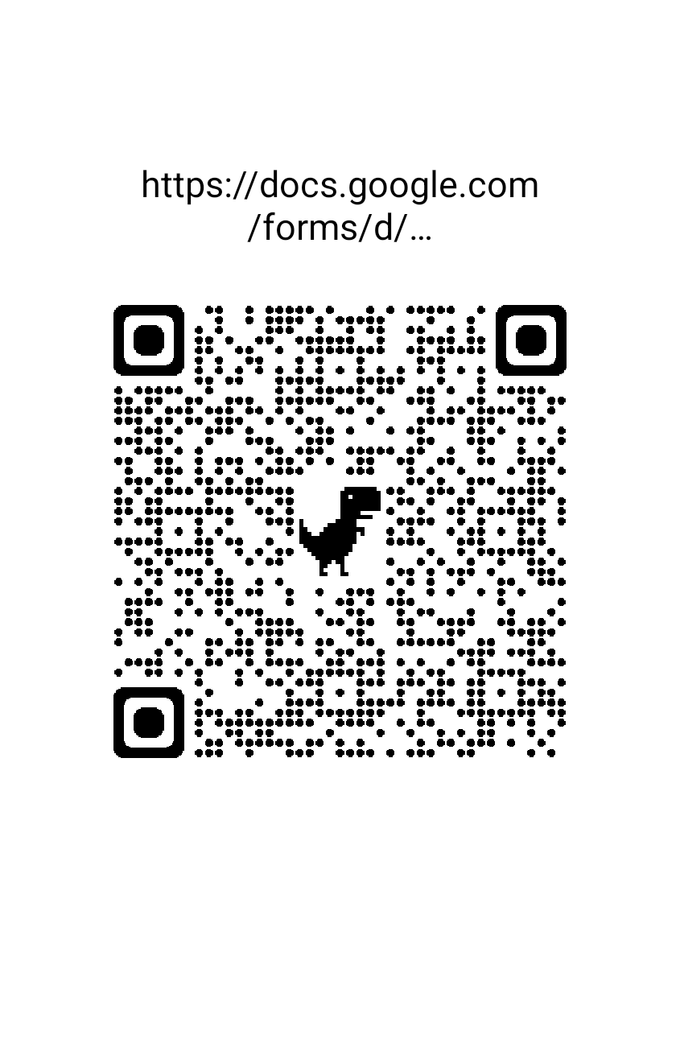
DONATE TO LAURALYNN

