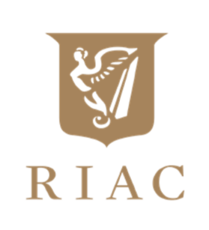

R.I.A.C. PROGRAMME OF EVENTS FOR 2022
Sunday 24th April, Cars & Coffee at the RIAC – 10am to 12 noon
At each Cars & Coffee event Coffee/Tea & Pastries will be available at €5 per person
Sunday 29th May, Cars & Coffee at the RIAC – 10am to 12 noon.
Sunday 26th June, Cars & Coffee at the RIAC – 10am to 12 noon.
Thursday 21st July, RIAC Picnic-in-the-Park, in Marlay Park – 4pm to 7.30pm
Sunday 31st July, Cars & Coffee at the RIAC – 10am to 12 noon.
Saturday 20th August, RIAC Classic & Sports Car Run
Sunday 28th August, Cars & Coffee in the RIAC – 10am to 12 noon.
Saturday & Sunday 3rd/4th September, RIAC Pioneer Run – based in Moyvalley
Sunday 25th September, Cars & Coffee in the RIAC – 10am to 12 noon.
Sunday 30th October, Cars & Coffee at the RIAC – 10am to 12 noon
Tuesday 6th December, Friends of the Archive Lunch in the RIAC.

Further details on any of the events can be obtained from Holly, RIAC administrator by phoning 01 6775141 or emailing info@riac.ie

